**THE TABLEAU HR SCORECORD: MEASURING SUCCESS IN TALENT MANAGEMENT:**

INTRODUCTION:

Talent management has become almost an inevitable management process in modern days. Talent management is an integral part of human resource management. Talent management is how employers recruit and develop a workforce that is as productive as possible and likely to stay with their organization long term.

PURPOSE:

* The function of talent development is to build employee knowledge, skill and attitudes so the organization can succeed and grow.
* Talent management is an organization aim at ensuring employee recruitment, training and development, performance review and their compensation.
* At the heart are the people the talent.

PROBLEM DEFINITION AND DESIGN THINKING:

* Problem understanding also known as problem definition or problem identification is the initial and critical phase of any data analysis or problem solving. It involves gaining a clear at hand, its context, scope and objective.

EMPATY MAP:



BRAIN STROMING

:

RESULT:

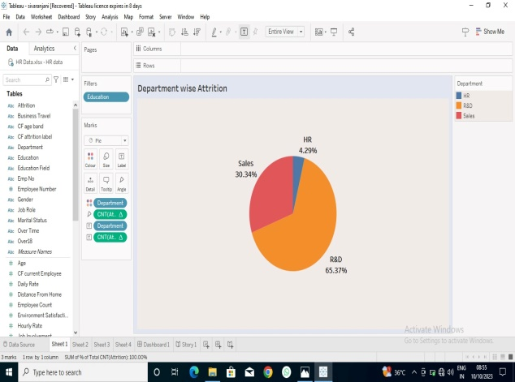

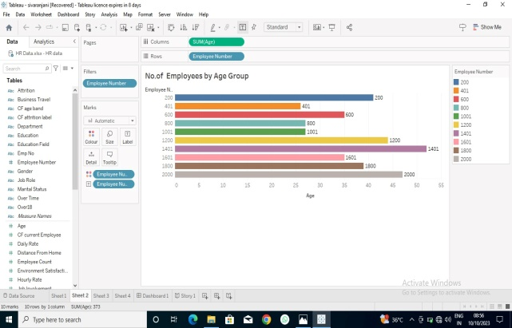

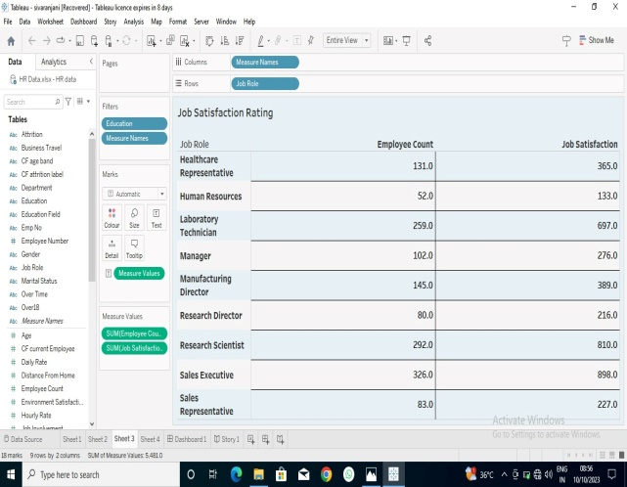



DASHBOARD:



STORY:

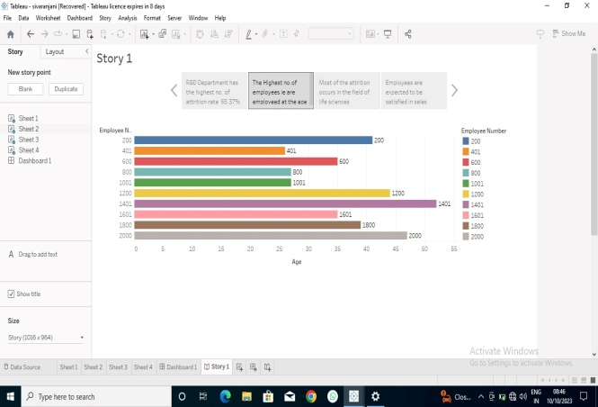:

ADVANTAGE:

* Helps in ascertaining the right person is deployed in the right position.
* Contributes in retaining their top talent.
* Better hiring by hiring assessments.
* Helps in understanding employees better and shaping their future.
* Promotes effective communication across different disciplines.

DISADVANTAGES:

* The implementation of talent management program could be expensive it terms of time, resource and financial costs.
* Lack of support from line managers can impede the level of commitment from employee.
* A core draw of talent managements is it can contribute in raising the conflicts between HR and management by not reaching to proper agreement or consensus.

APPLICATION:

* TIME-TO-FILL:

Measuring of amount of time is takes to fill as open position.

* Measuring the cost of recruiting and hiring a new employee.
* Employee turnover rate.
* High potential talent.
* Talent mobility.

CONLUSION:

The success if talent management’s strategy hinges on its ability to adopt, align and deliver tangible result. Measuring this success is not confined to number alone, it’s a multifaceted endeavour that marries data with objectives

FUTURE SCOPE:

* Measuring success effectively, it’s crucial to identify relevant key performance indications for aspect to talent managements.
* Key performance indicators could include metrics such as employee turnover rates, time-to-time position , training completion rates, and employee satisfaction sores